How to raise ICCM request for **PlatformAutomationAndServices** .

Link to open ICCM Request : <http://servicedesk>

**For V3 version e-service desk users.**

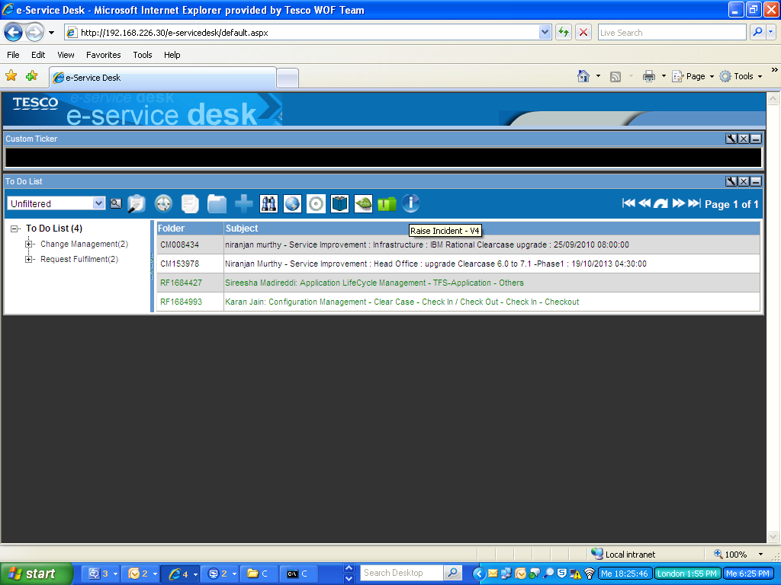

Click on Blank Form icon

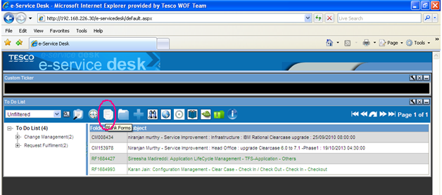

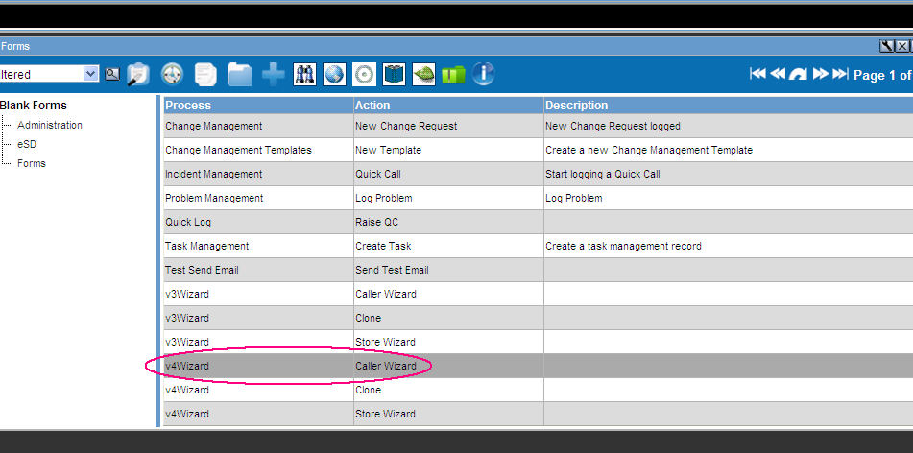

Select the V4vizard – Caller Wizard(If V4wizard not displaying in the Current page 1 go to Page 2)

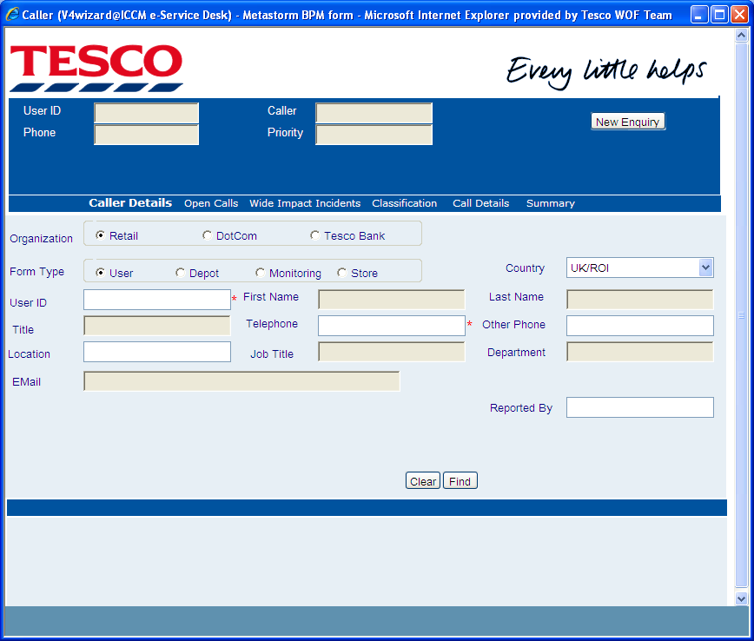

Enter the user id: tpx id: Eg: ye66

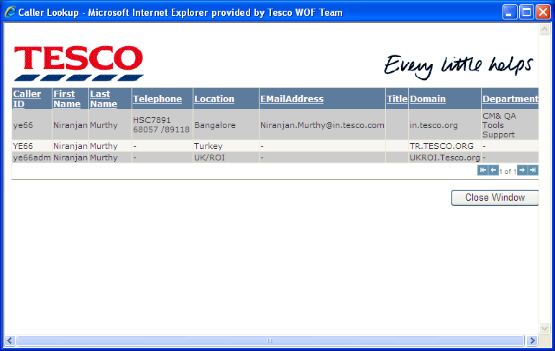

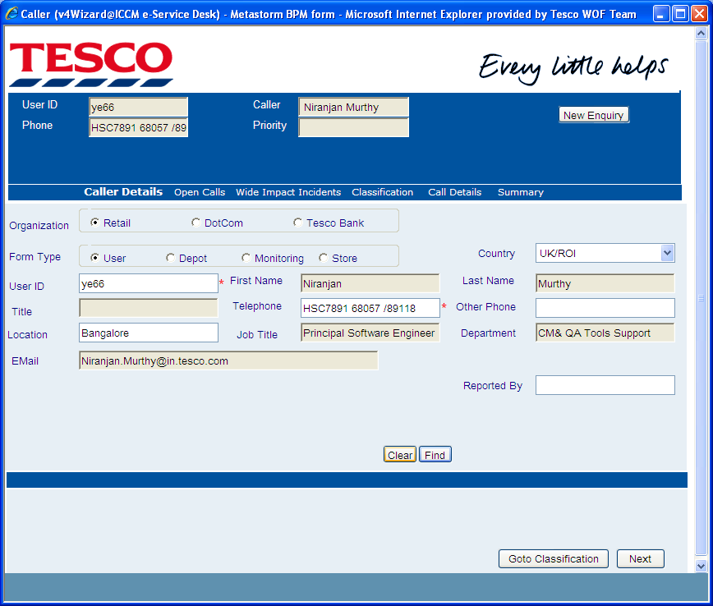

Click on Goto Classification and Select the Business area and Select **PlatformAutomationAndServices**

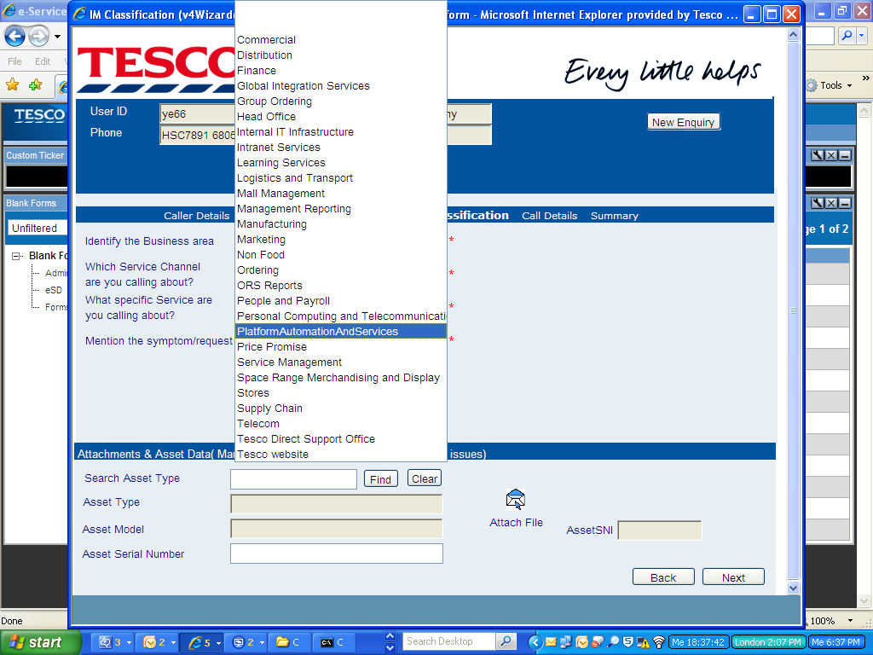

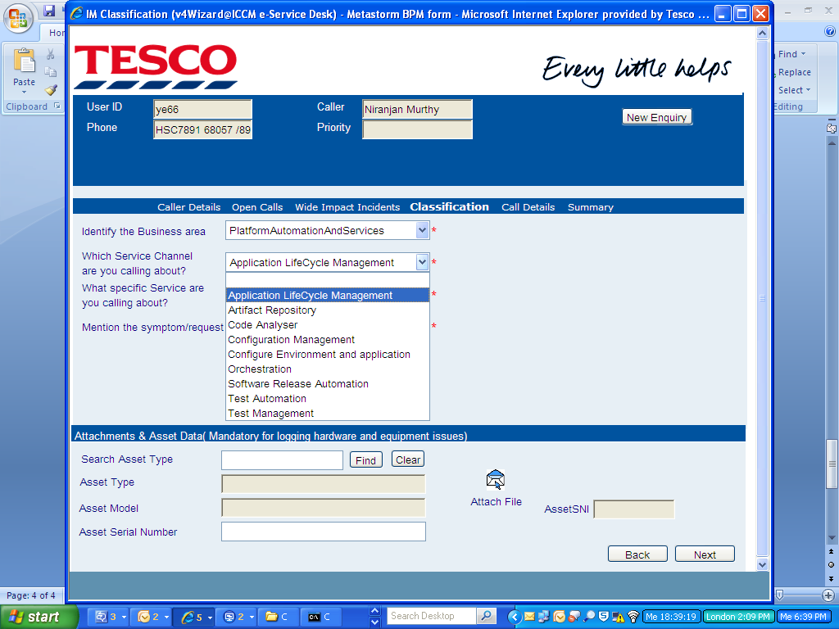

Select the Appropriate Service channel to raise a request.

Raise the request with ICCM version 4.

Link to open ICCM Request: <http://servicedesk>

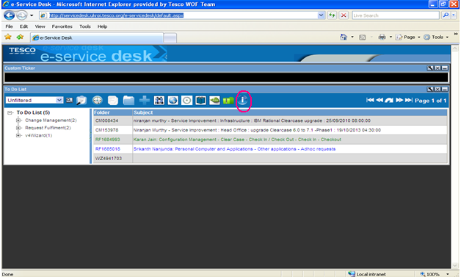

Select the Icon marked in Red circle



Enter the user tpx id: Eg: ye66 and Click on find button



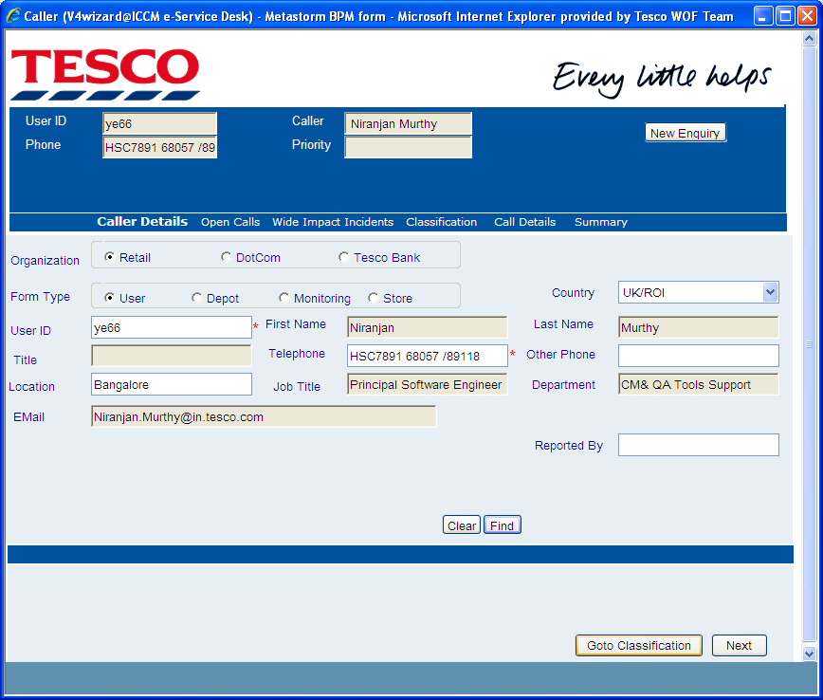

Select Goto Classification and Select the Identify the Business area as ”PlatformAutomationandServices “

